**Тема:**  «Вычисления по формуле. Индукционный закон Фарадея »

**Цель:** Повторить грамматический материал , продолжить изучать лексическую тему «электротехника».

**Задачи:** Отработать навык работы (в т.ч. перевода) с профессиональной лексикой по теме «электричество», повторить тематический материал, актуализировать имеющиеся знания.

**Специальность:** 13.02.09 Монтаж эксплуатации линий электропередачи, 13.02.11 Техническая эксплуатация и обслуживание электрического и электромеханического оборудования (по отраслям)

**Время выполнения:** 90 минут

1. **Study the new words.**
2. **Read the text.**
3. **Do the tasks.**

**Faraday’s Law of Induction**

The famous author Isaac Asimov once said, “The most exciting phrase to hear in science, the one that heralds new discoveries, is not ‘Eureka!’ (I found it!) but, ‘That’s funny. …’ ” *That might have been what Faraday thought when he noticed the meter deflection upon connecting and disconnecting the battery.* Even though he didn’t get the result he was looking for — current flowing steadily via the secondary coil — he did see a hint of current flow in the form of a slight needle deflection in the galvanometer. But it was enough to lead him down the right path to the answer. *Eventually, he found that a stationary magnetic field does not induce current in the secondary coil, but that a changing magnetic field does.* When a battery is first connected to a circuit, the magnetic field has to build from zero to its maximum. *As the field grows, the lines of flux of the magnetic field cut the turns of wire in the secondary coil, thereby inducing a current.* Faraday deduced that a changing magnetic field whose lines of flux cut through a wire will generate a voltage. The value of the voltage is proportional to the rate of change and the intensity of the magnetic flux. This is known as Faraday’s law of induction. *According to Faraday’s law of induction, it doesn’t matter whether the lines of flux are cutting through the wire or the wire is moving through the lines of flux, as long as they are moving relative to each other.* Therefore, a wire can move through a stationary magnetic field or a magnetic field can move through a stationary wire and it will still generate voltage. What is important is that the wire is not moving parallel relative to the lines of flux (0°), otherwise no lines of flux will be cut and no voltage will be generated. The movement can, however, be somewhere in between parallel and perpendicular (90°) relative to each other; then some lines of flux will be cut and a proportional amount of voltage will be generated*. For example, if a wire is moving at a 60° angle through a magnetic field, then it is cutting half as many lines of flux as another wire traveling at a 90° angle to the magnetic field at the same rate of speed.* *Therefore, it would generate half the voltage.*

1. **Translate the lines given in italics.**
2. **Find equivalents for the followings:**
3. Равномерно проходящий ток
4. Верное направление
5. Формироваться с нуля
6. Сокращать обороты
7. Пропорциональный объем
8. **Fill in the gaps with the following words:** circuit;quantitative; magnetic; scientist; wire.

**Faraday’s law of induction**, in [physics](https://www.britannica.com/science/physics-science), a __________________________________relationship between a changing [magnetic field](https://www.britannica.com/science/magnetic-field) and the [electric field](https://www.britannica.com/science/electric-field) created by the change, developed on the basis of experimental observations made in 1831 by the English ___________________________[Michael Faraday](https://www.britannica.com/biography/Michael-Faraday). The phenomenon called [electromagnetic induction](https://www.britannica.com/science/electromagnetic-induction) was first noticed and investigated by Faraday; the law of [induction](https://www.merriam-webster.com/dictionary/induction) is its quantitative expression. Faraday discovered that, whenever the________________________________ field about an [electromagnet](https://www.britannica.com/science/electromagnet) was made to grow and collapse by closing and opening the [electric_________________________](https://www.britannica.com/technology/electric-circuit) of which it was a part, an [electric current](https://www.britannica.com/science/electric-current) could be detected in a separate conductor nearby. Moving a permanent [magnet](https://www.britannica.com/science/magnet) into and out of a coil of ___________________________also induced a current in the wire while the magnet was in motion. Moving a conductor near a stationary permanent magnet caused a current to flow in the wire, too, as long as it was moving.

1. **Learn the law and work with the formula, explain the Faraday’s law of induction in a form of equation:**

**Faraday’s law** of induction states that an electromotive force is induced by a change in the magnetic flux.

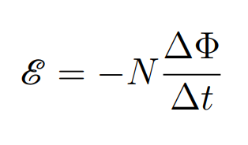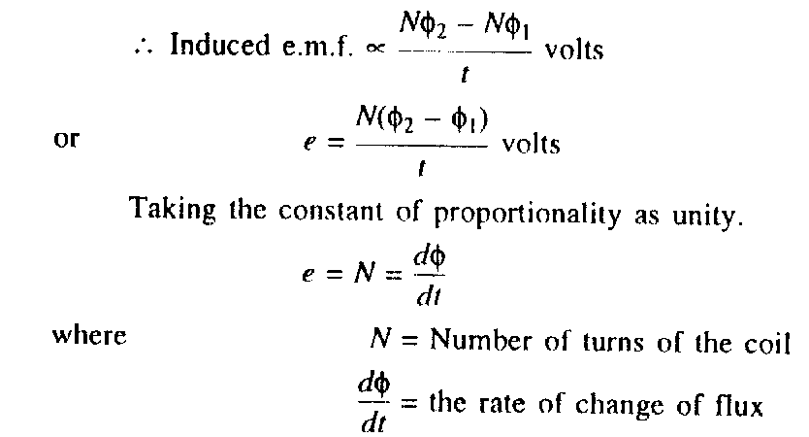



1. **Solve the following:** <https://physexams.com/lesson/Faradays-law-equation-solved-examples_26>
2. **Do the quiz:**

<https://www.britannica.com/quiz/electricity-short-circuits-direct-currents>

